**Nama : Dini Tri Widianingsih**

**No. Peserta : FSDO003ONL007**

**SESI 09**

1. **WEATHER FORECAST**

**API : GET**

1. SWAGGER

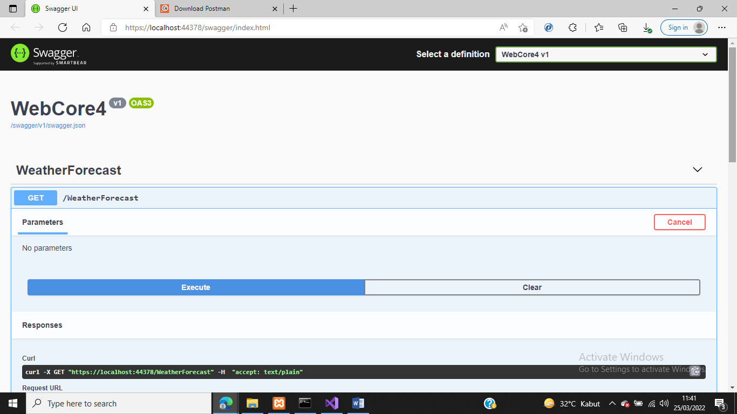

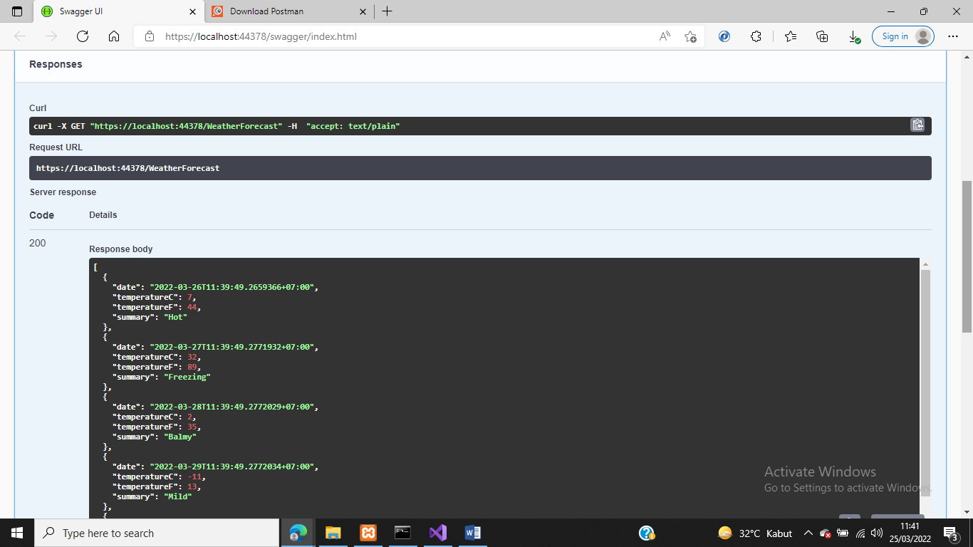

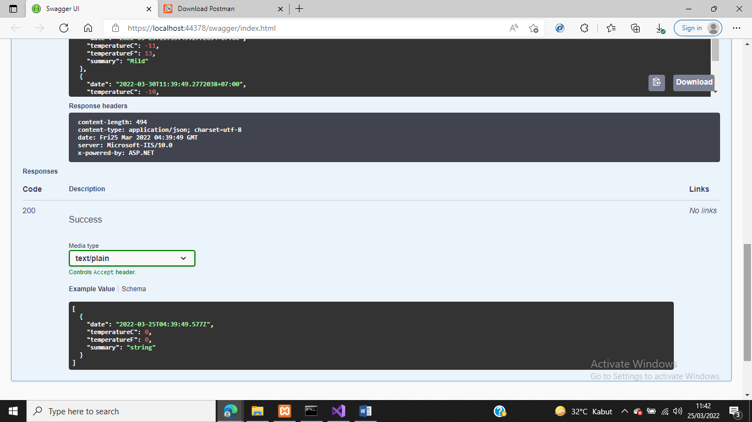

1. WEBSITE

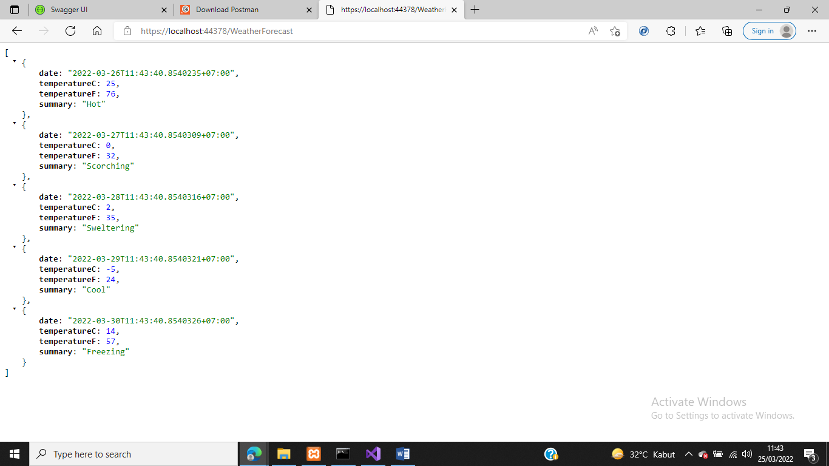

1. POSTMAN

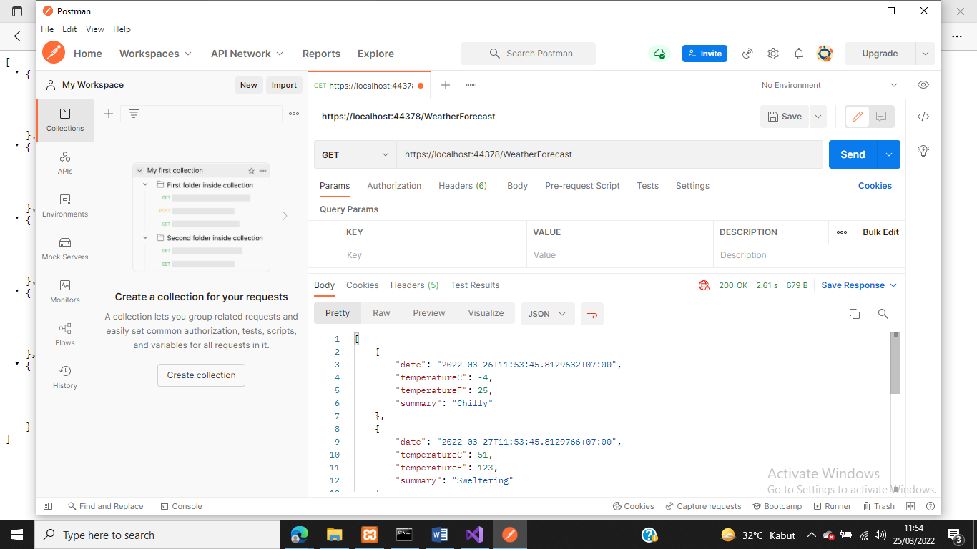

1. **EMPLOYEE**

**API : GET**

1. SWAGGER

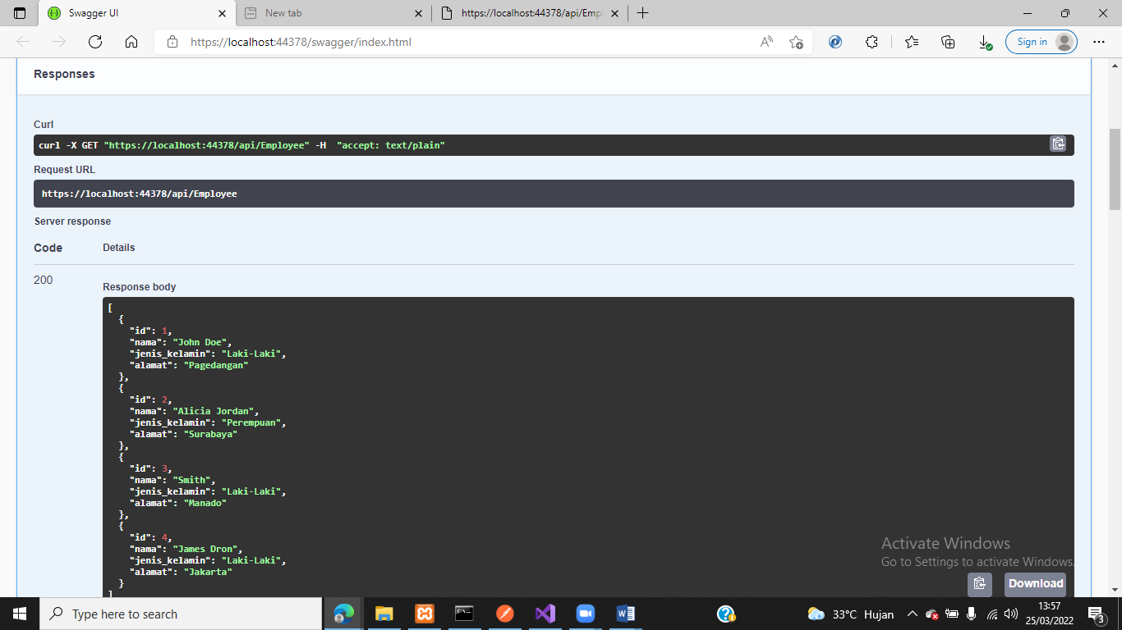

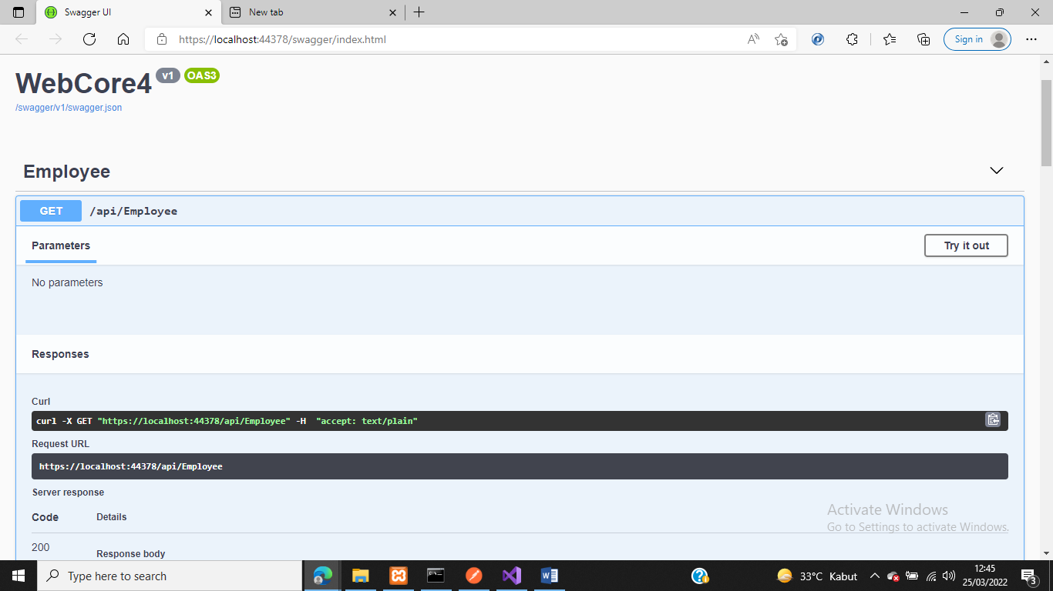

Mencoba memasukan id = 1

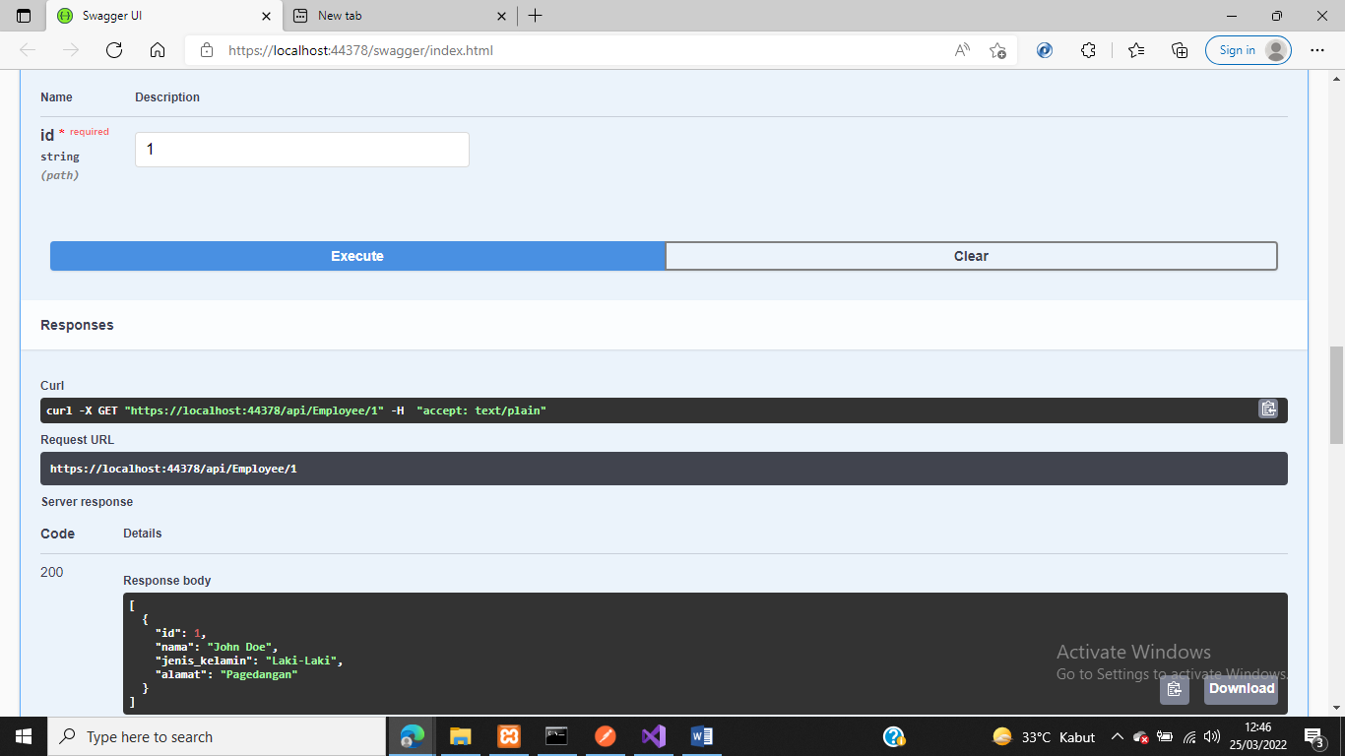

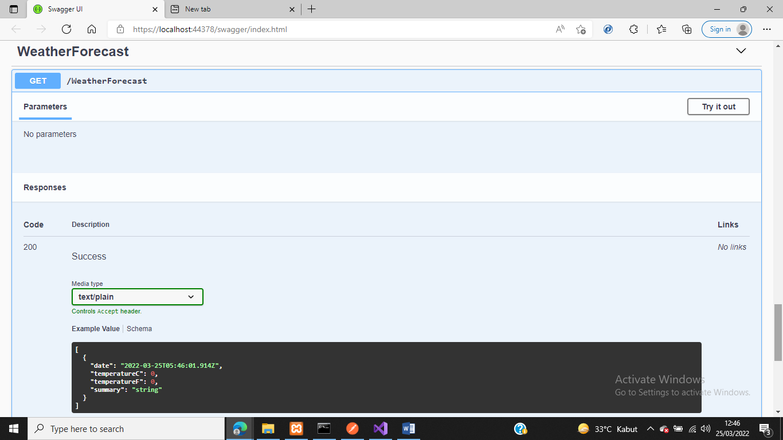

1. POSTMAN

* Url : <https://localhost:44378/api/Employee/1>

Memasukan ID = 1, Lalu keluar data ID employee = 1

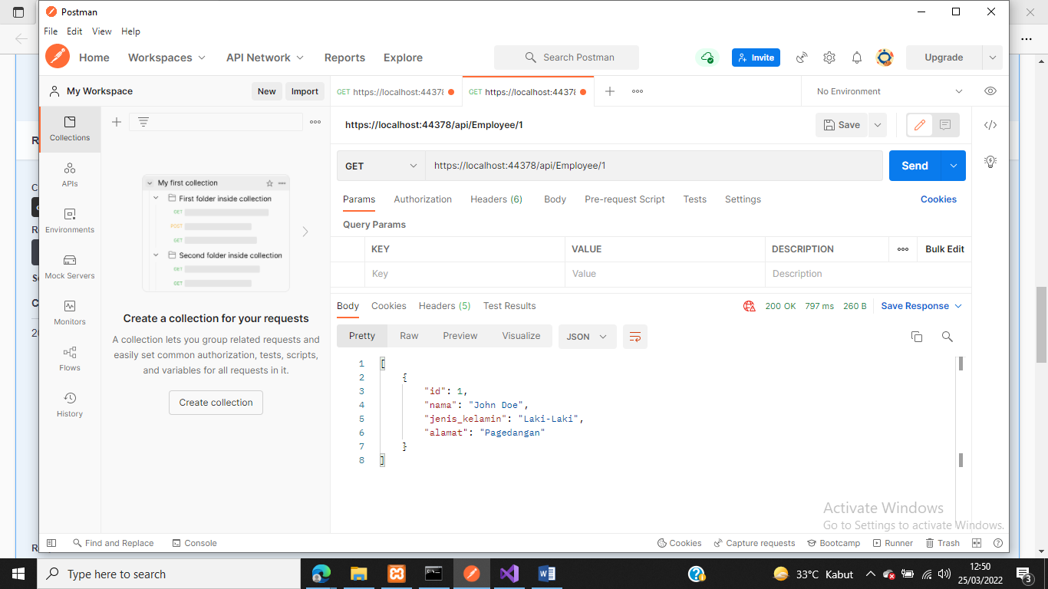

* Url 2 : <https://localhost:44378/api/Employee/2>

Memasukan ID = 2, Lalu keluar data ID employee = 2

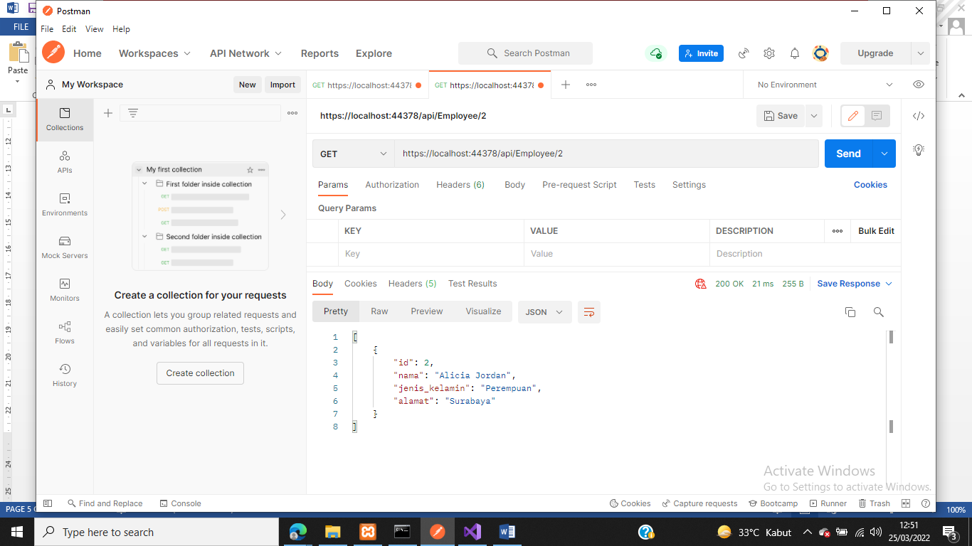

1. WEBSITE

URL : <https://localhost:44378/api/Employee>

